To download Pentbox from GitHub in Linux, you can follow these steps:

Open a terminal on your Linux system.

Make sure you have Git installed. If not, you can install it by running the following command:

sudo apt-get install git

Change to the directory where you want to download Pentbox. For example, if you want to download it in your home directory, use the following command:

cd ~

Clone the Pentbox repository from GitHub using the following command:

git clone https://github.com/white-hackers/pentbox-1.8.git

Once the cloning process is complete, you will have the Pentbox files on your local system.

Now you have successfully downloaded Pentbox from GitHub to your Linux machine.

After installation open pentbox

Go pentbox folder using cd pentbox

Run pentbox using ./pentbox.rb

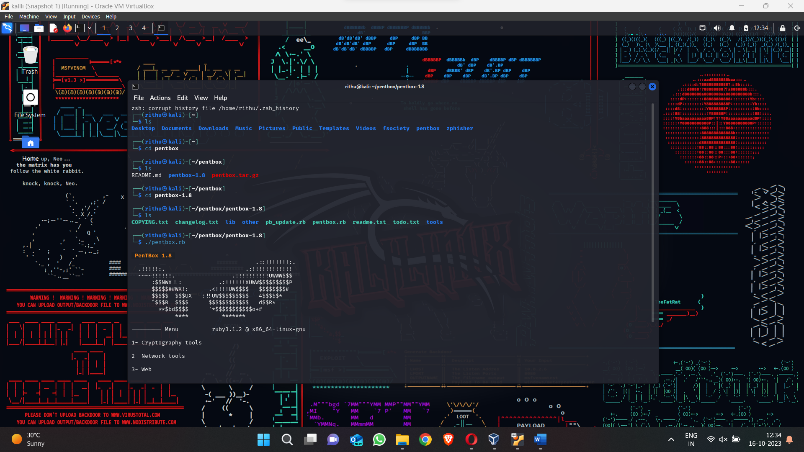

Set up honeypot by going to network tools and then honeypot

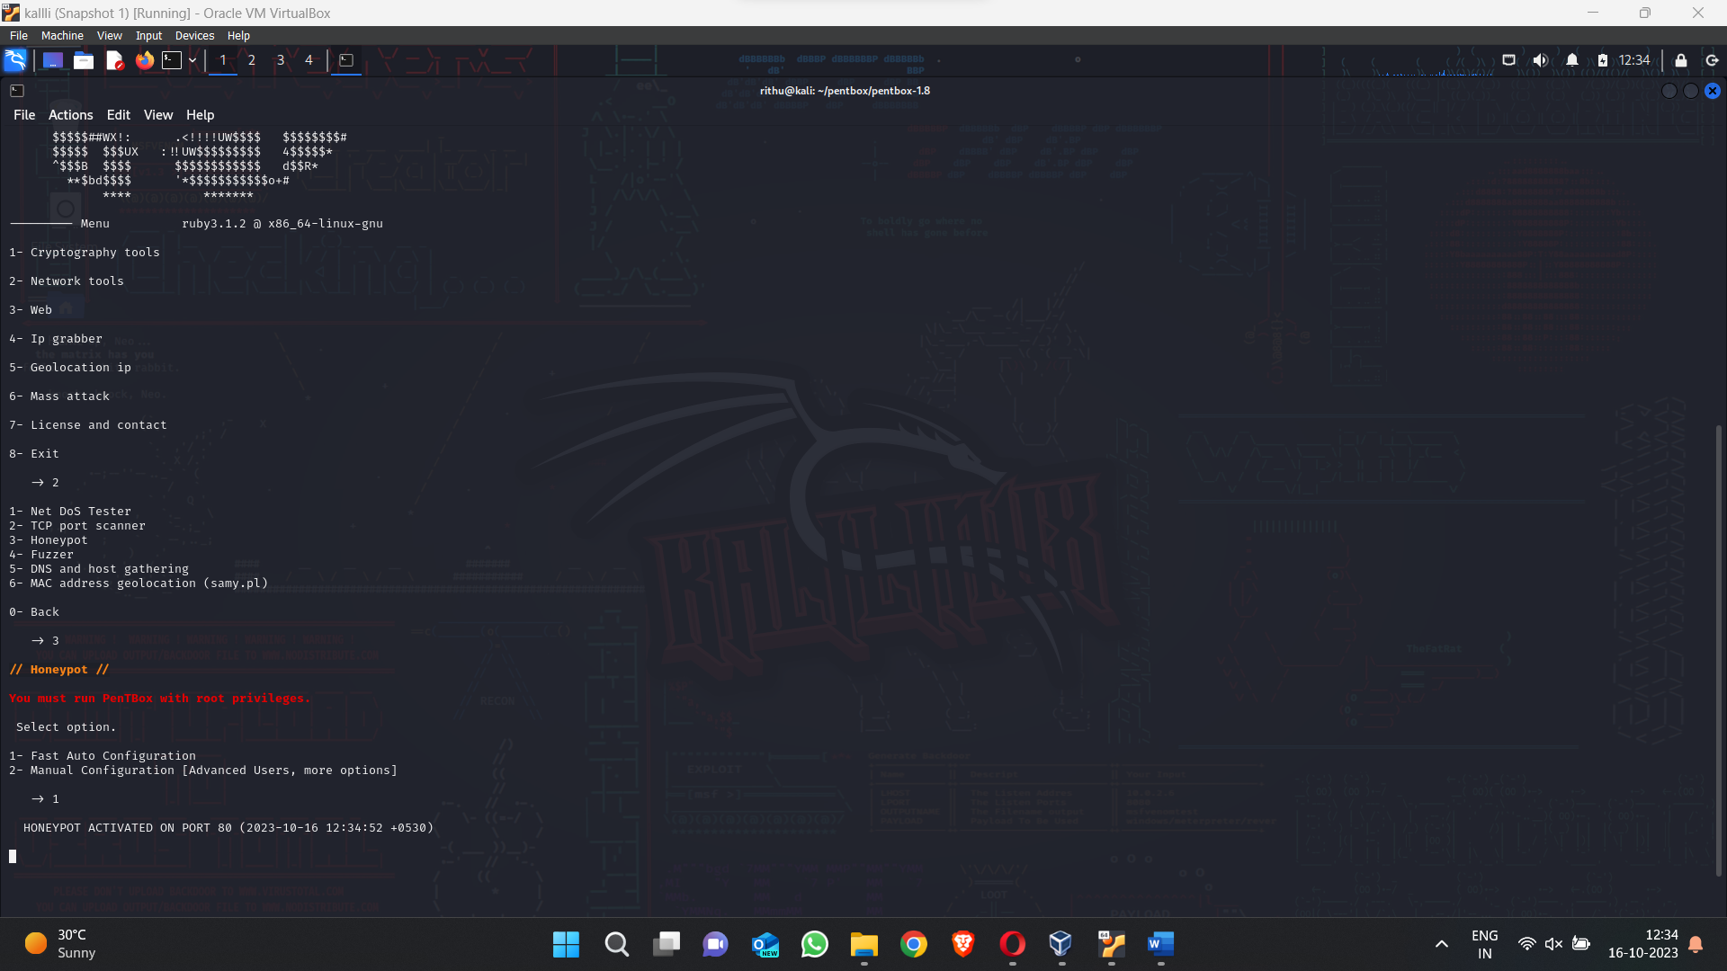

After honey pot is setup open the Ip address page in browser to check if it is work

Here access is denied because honeypot is active

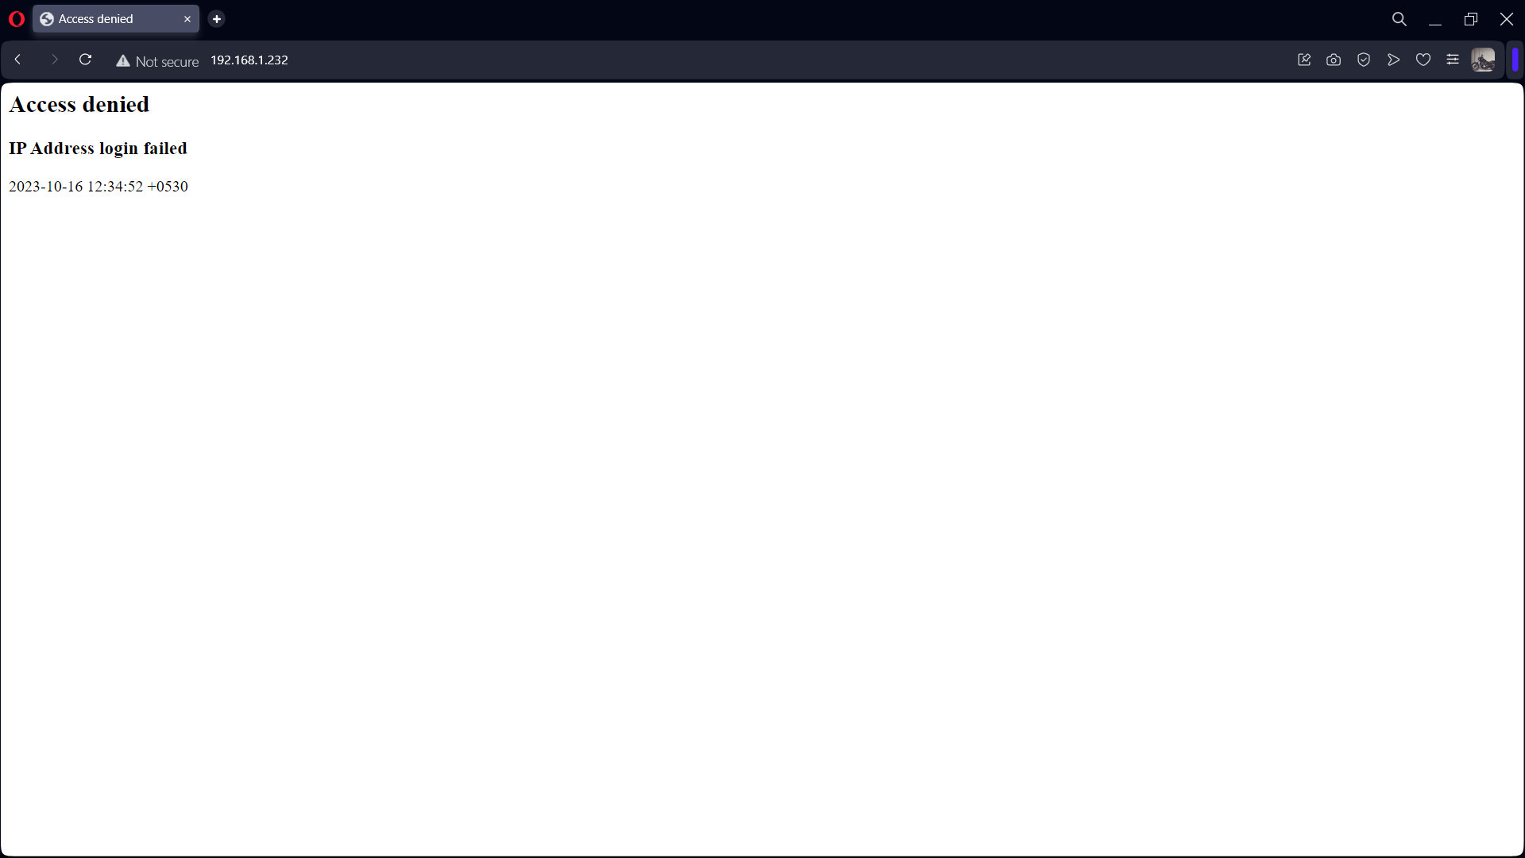

As the browser’s action is denied honeypot gets an alert that this specific browser is trying to intrude into our network

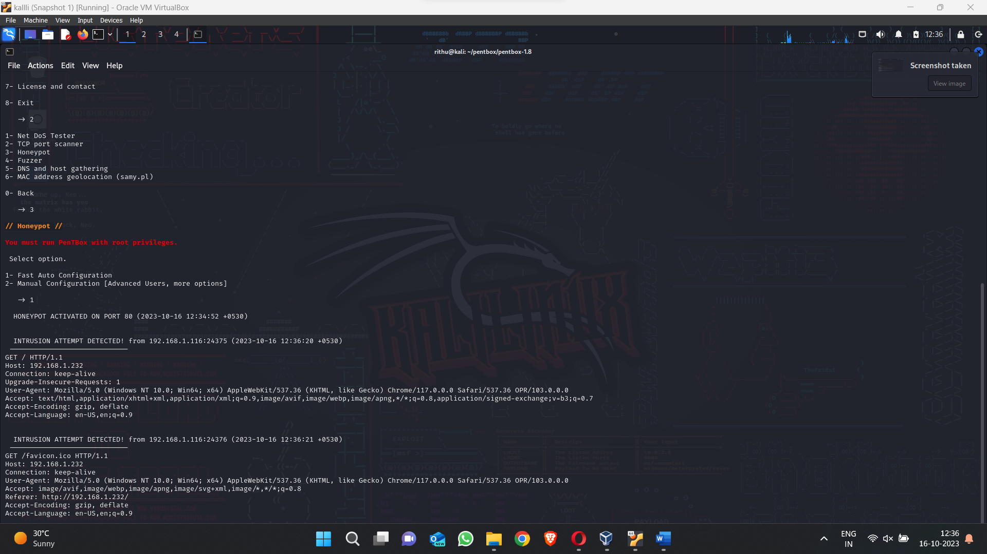

Let us check how honeypot responds to a DOS attack

Let us use LOIC tool to perform DOS in local server by entering the IP of the system where honeypot is running “192.168.1.232”

Set up a message, method and no. of threads and click “imma chargin mah laser”

If DOS attack is successful the requested packets will show

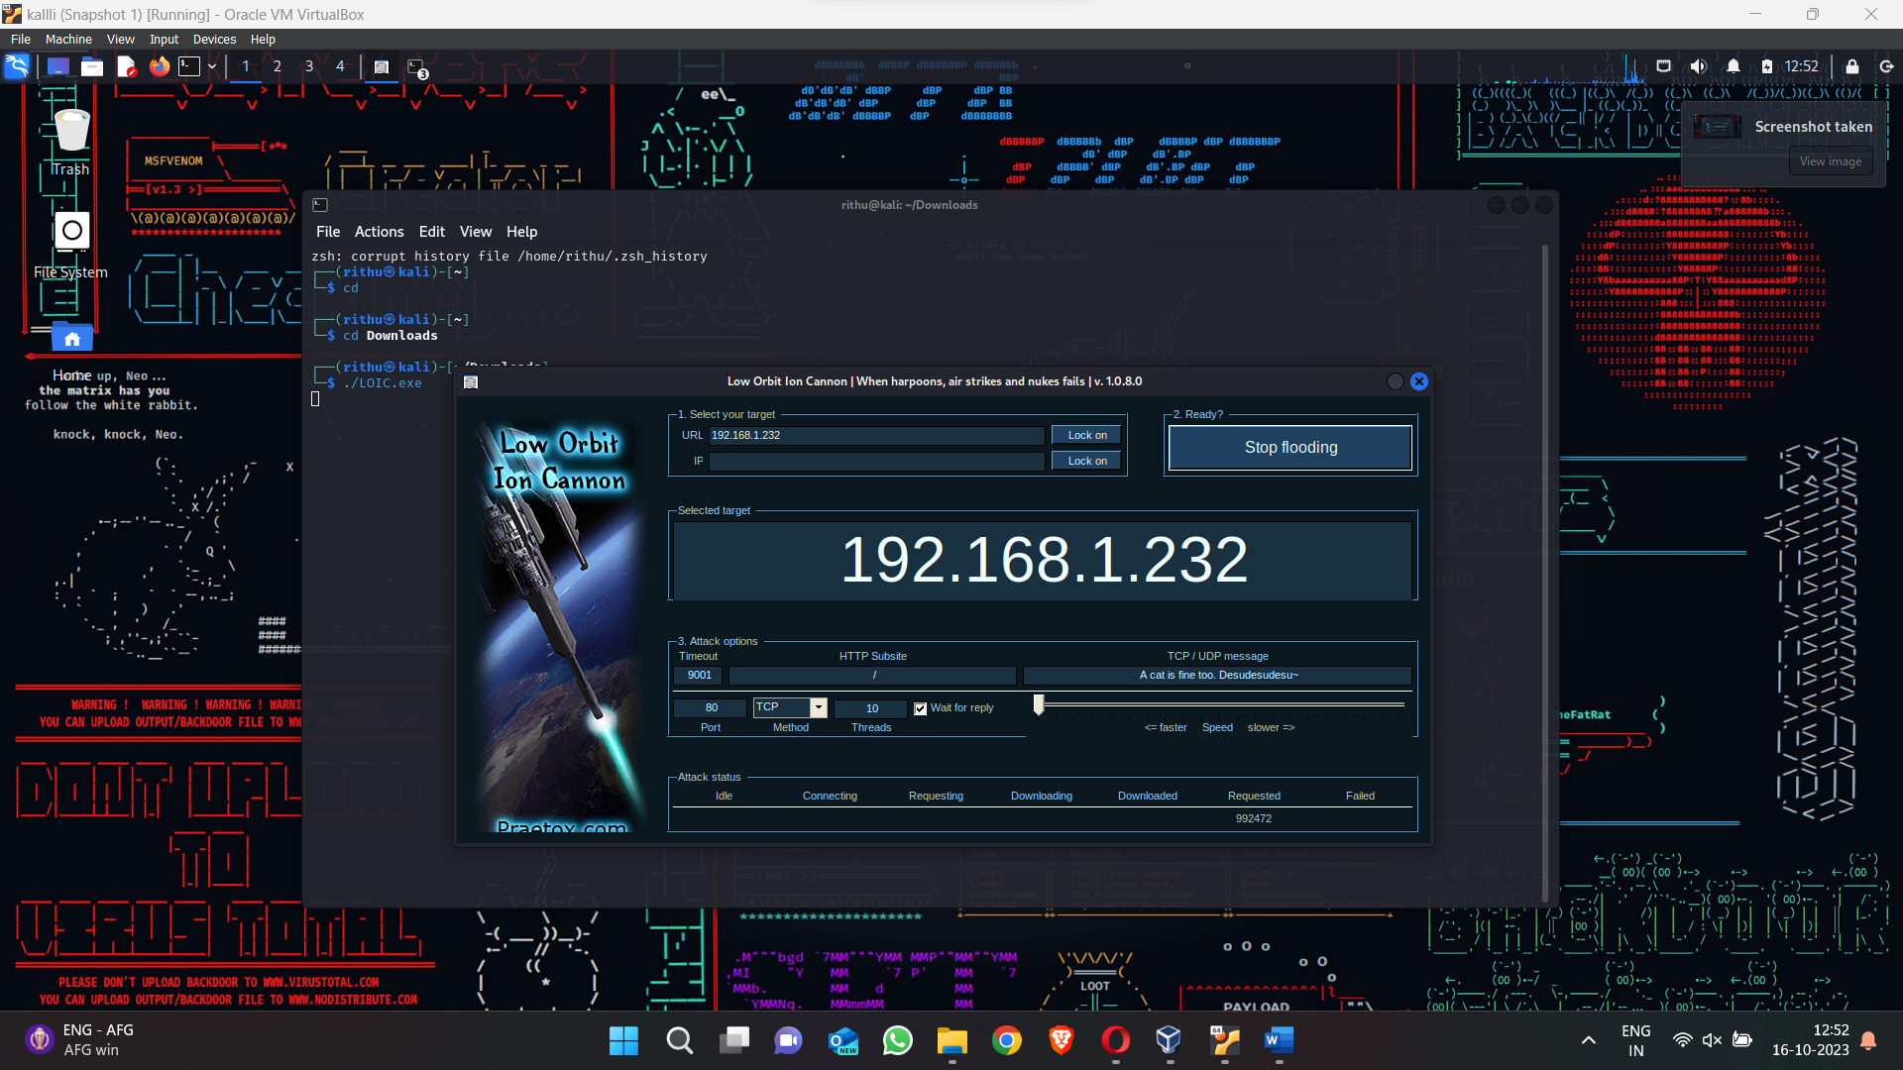

As DOS attack is going on honeypot gives us alerts that an intrusion attempt is detected and gives the message from dos attack

